4.3 System Architecture Diagram
Figure 4.3 illustrates the high-level system architecture of the "Lost and Found Board" application, designed using the Model-View-Controller (MVC) architectural pattern. This structure separates the system into three interconnected layers to ensure modularity and maintainability:
- Presentation Layer (View): Represents the client-side interface where users interact with the system via the web browser.
- Application Logic (Controller): Acts as the intermediary that processes HTTP requests through a central routing mechanism and directs them to the appropriate controllers (e.g., Auth, Post, Search) to handle business logic.
- Data Layer (Model): Manages the data and logic of the system, handling direct queries to the database to retrieve or store information such as user details, posts, and claims.

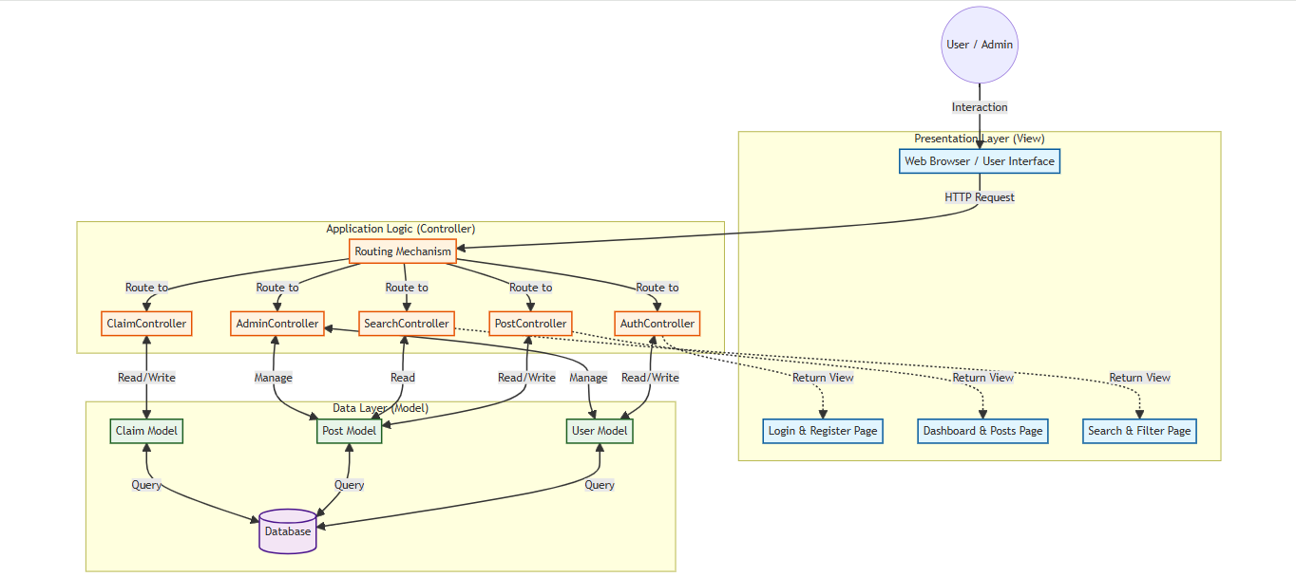

Figure 4.3: System Architecture Diagram
for Lost and found board

